**Cuba Country Case Study**

*Introduction*

The Republic of Cuba, an upper-middle income country[ref] of 11 million located in the Caribbean, has been widely lauded for its efforts, both in Cuba and abroad, to stem the pandemic. In the past decade, Cuba is known for its abundance of doctors per capita, has made widely renowned progress against malaria and tuberculosis, and additionally has one of the lowest maternal and child mortality rates for the region (see Figure XX). Cuba’s GDP per capita in 2019 was about US$8,800, which put it towards the lower end of the region [WB], and it had a pandemic preparedness index score of 35.2, which ranked it 110/195 in the world [GHS index].

Though Cuba derived some of its success in stemming COVID from its ability, as an island nation, to quick halt international travel, it also derived benefits from its preexisting disaster-response institutions, its strong primary health care system and workforce, and its quick government response[ref]. Cuba’s response is all the more interesting because of its difficult economic circumstances, which are due in part by a United States embargo which prohibits the normal trade of food, medicine, and medical equipment (Keck and Reed 2012); Cuba thus might shed light on some lessons learned for other resource-constrained countries. Ultimately, Cuba’s success to date in stemming the transmission of COVID-19, and thus having one of the lowest COVID-19-atttributable mortality rates regionally (Barmejo et al 2020), is indicative of a tradeoff made by the government between civil liberties and the quick stemming of the pandemic.

Figure XX. Trend of Selected SDG-3 Indicators Before the COVID-19 Pandemic (2009-2019), Cuba

*Overview of the health system and progress towards UHC*

Cuba currently has a single, universal health system with national coverage and free-of-charge care for patients (Gail Reed 2020). Almost all health facilities are government owned and operated; though the health system was centrally developed, local flexibility has been highlighted such that localized health incidents can be readily addressed (Keck and Reed 2012). The health system is split into three hierarchical levels which interlock: *consultorios* (family doctor clinics); *policlinicos* (specialty clinics which provide secondary care; and hospitals and *institutos* (hospitals and medical institutions which provide tertiary care). At the first level, family doctor clinics generally serve a population of between 600 and 900 patients. At the second level, each polyclinic serves a geographic region of about 25,000 to 35,000 people. In any given location in the country, a polyclinic is usually located within a few blocks. And at the third level, circa 2008 Cuba had 256 hospitals and 13 medical research centers (Offredy 2008).

Given Cuba’s centralized and free-of-charge health system, Cuba has made robust progress towards achieving UHC. Cuba has long stressed the importance of population health (Pol de vos 2019); during the crisis of the 1990s, Cuban health services infrastructure rapidly deteriorated. Later, recuperation and modernization were key strategies: human resources for health were a key priority, as well as strengthening professional development and family medicine and support services of policlinics (pol de vos 2019). The medical training curriculum has in many ways reflected the Cuban health system, focusing on population health and public health measures (Campion and Morressey, 2013). Cuba has additionally focused on rural health: a Rural Medical Service (RMS), established in 1960, has been a precursor to later models which embedded health professionals in underserved communities (Keck and Reed 2012).

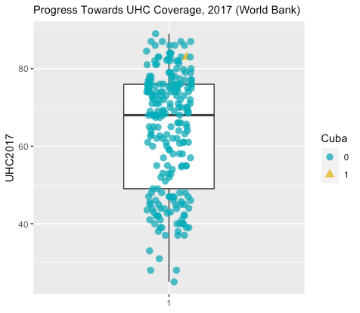

Though Cuba has attracted praise for its achievements in matters of health and the robustness of its National Health System (SNS) (Morales and Fitzgerald, 2018), other scholars however note that the government of Cuba has previously manipulated key health statistics, such as the infant mortality rate (IMR), for political legitimacy (Gomez-Dantes, 2018).

*Pandemic preparedness and response capacity*

Though Cuba had a low pandemic preparedness index score of 35.2, which ranked it 110/195 in the world [GHS index], it also posessed several underlying factors that enabled a disproportionately robust response capacity.

First, Cuba has a history of implementing the requisite steps to contain—and, in 11 cases, eliminate—immunopreventable diseases (Morales and Fitzgerald, 2018). Cuba was the first country in the world to certify elimination of the vertical transmission of HIV and congenital syphilis in 2015 (Caffe et al 2016; Morales and Fitzgerald, 2018). Part of Cuba’s ability to contain and control HIV was the strict state control over its population’s health—Cuba is the only country where HIV detection tests are obligatory and where at least until recently people with HIV were confined (Gomez-Dantes, 2018). Cuba also eliminated malaria in 1976 as the first country in Americas, which, to date, is only followed by Paraguy in 2018 and by El Salvador in 2021[ref], These active steps rest upon an already strong bedrock of clinical preventative services and active surveillance effort; Cuba has one of the highest full immunization by 2 years statistics (Keck and Reed 2012).

Second, though Cuba has not been affected for decades by large scale infectious disease outbreaks, Hurricane Imra in 2017 serves as a prime example of the country’s emergency preparedness and public health response capacities. Fast resource re-alllocation (e.g., creating extra hospital beds in major healthcare facilities), pre-emptive staffing of medical workers in rural areas, and healthcare facilities equipped with emergency power generators to anticipate electricity loss all concurrently enabled uninterrupted healthcare service provision during and after Irma. Post-hurricane epidemiological surveillance revealed no occurence of waterborne and/or gastroenterities disease outbreaks across the country. Cuba is also an active international player in supporting other countries’ emergency response capacities. The country dispatched healthcare workers to support numerous hurricane damages in Carribean countries, as well as the two major Ebola virus disease outbreaks in African countries[ref].

Third, Cuba had its strong progress towards UHC, which included extremely strong primary health care, a large and well-trained workforce, and the presence of strong research centers organized for innovation (Gail Reed 2020). By the end of 2016, more than 2,000 health investigations were being carried out in Cuba by more than 3,200 researchers (Morales and Fitzgerald, 2018). That said, about half of Cuban physicians work in international missions and many are gynecologists (Gomez-Dantes, 2018). Outside of the health context, Cuba also has ample experience in disaster mitigation, developing disaster preparedness institutions that have been used not just during epidemics but also during tropical hurricanes (Salas 2020). Cuba was arguably thus one of the most prepared countries for COVID-19, though much of this preparedness came due to a particular political context that raises questions about civil liberties (Wenham and Kittelsen).

*Response to COVID-19*

In January 2020, Cuba activated the National Temporary Group to intersectorally confront the pandemic, outlining the policies of government, communication, and science and technology (Bermejo et al 2020). Cuban authorities subsequently followed international guidelines, conducting contact tracing, isolating suspected cases, and mandating the use of masks in public places (Perez Riverol 2020). The first case of COVID-19 was confirmed in Cuba on March 11, 2020 (Galban-Garcia 2020). On March 22, 2020, Cuba announced the selective closure of its international borders at airports and recreational ports; this was at a time when the country had fewer than 50 confirmed cases of COVID-19 and only one death. Simultaneously, all public events that could not be safely socially distanced were suspended. Authorities thereafter activated Cuba’s defense councils, which decentralize the chain of command, and instituted interprovincial checkpoints to enforce mobility bans; by mid-May, the Oxford Stringency Index gave Cuba its highest evaluation for governmental response (Hale et al 2020; Salas 2020). During the three months after the first case was confirmed, Cuba also instituted some unique measures, including instituting a nationwide door-to-door active screening for individuals with COVID-19 symptoms; some have attributed much of Cuba’s success to these proactive measures (Galban-Garcia 2020).

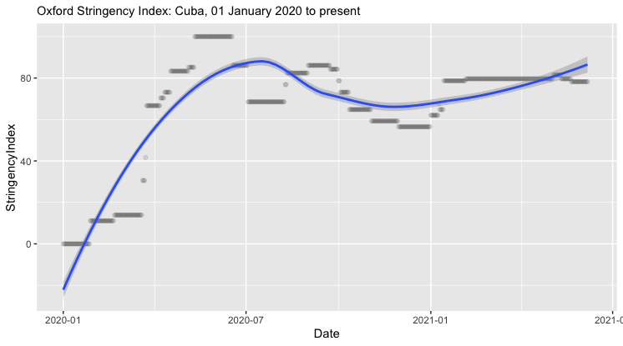

After the immediate governmental response, Cuba relied on its primary healthcare workers to carry out a proactive nationwide campaign of disease surveillance and community outreach (Salas 2020). Cuba’s research centers continued working through the pandemic; by October 2020, Cuba had four vaccine candidates and Cuba’s Finaly Vaccine Institute had a promising vaccine candidate, SOBERANA 01 (Gail Reed 2020). Cuba additionally focused some of its efforts abroad, garnering positive international reactions as stories of Cuban doctors being flown around the world widely circulated; these stories were reminiscent of similar praise garnered by Cuban doctors who flew to help during the Ebola epidemic (Samuels 2020; Salas 2020).

As the pandemic spread throughout Latin America, Cuba became a relative regional success story. Explanatory factors included Cuba’s universal health system, particularly the services provided by family doctors and nurses at the first level of care (Samuels 2020). Other measures included Cuba’s previous history controlling communicable diseases, the swift closing of borders, the restriction of movement across the country, and nationally manufactured pharmaceuticals which proved effective at controlling some of the more severe COVID-19 symptoms (Samuels 2020; Yaffe 2020). However, despite the prevalence of locally available doctors there were still urban-rural disparities in the level of care offered and available throughout the pandemic (Samuels 2020). We also note that though Cuba garnered praise for its response to COVID-19, its economy was hit hard, and the pandemic amplified preexisting social inequities (Salas 2020).

*Conclusion*

Cuba’s accessible healthcare system through well-established primary care throughout the country, disaster preparedness and response capacities bolstered after each event of disasters, namely hurricanes, and universal health system institutions operated by healthcare professionals whose training includes immense focus on the importance of public health, coupled with the agile and committed government, enabled a quick, effective, and adaptive response (Aguilar-Guerra and Reed 2020).

*Takeaways*